Minutes of March General Membership MEETING
Happy Trails Stitchery Club
April 5, 2022
HT Stitchery Club was established on February 27, 2006

The meeting was called to order by President Janet Leffel at 2:00 PM. Board members present are as follows: President Janet Leffel, Vice President Mickey Astin, Treasurer Gerry Yakovleff. Secretary Donna McCullough. New members welcomed were: Kim Yakovleff and Leah Redifer, both from WA.

TREASURER’S REPORT:
- An audit will occur in the fall. We opened new checking and savings accounts with the Happy Trails EIN for nonprofit groups. As per Barb Fugelberg, we are a 501C7 social group as we make less than $50,000 per year.
- Last year’s budget was reviewed and a new budget is being created. $3,000 from savings was used to buy new machines and $1,200 will be used to clean the machines. Karen Moes asked about a budget for the Christmas party and will submit that. Attachment.
- Auxiliary Membership was suggested for HT owner-members who can’t currently live onsite. They could pay half the dues, have voting privileges, Zoom meetings & receive minutes. Attachment.
- Current balance is:
- $4,211.70 the checking account
- $5,878.75 in the savings account

SECRETARY’s REPORT:
- The Membership Meeting minutes from March were approved and accepted. Karen Moes moved and Nancy Escott seconded that the minutes be approved. Motion passed.

VICE-PRESIDENT:
- Mickey reported writing an article for the Nosey Coyote and also is working on a new logo for the club. She is working with Janet on Machine Maintenance; Sun Valley Quilts is a possibility. Claire spoke highly of the repairman from Sun Valley Quilts.
- Several committees are still needing volunteers.
- Janet & Mickey are planning summer hours and will inform Thelma in Activities.
- Missy proposed asking outside teachers/speakers to guest teach or speak.

MONITOR’S REPORT:
- 10 monitors out of 42 trained monitors served in March. Monitors will need to take a refresher class in the fall as the door code will be changed and distributed after the class is taken. People need to monitor once a month to have the code to the door. Billie Dunphy won the monitor drawing.

OLD BUSINESS:
- Stitchery donated $75 for free coffee to the Chuck Wagon; a sign could be created for advertising that we donated free coffee. We will be working more on marketing next year.
- The Stitchery room is closed during classes and a sign will be placed on the door.
- Valentine Dinner Dance. Beth Engstrom reported she delivered the auction items to Chef Peters which he purchased.
- Fashion Show with New Image. The date will be March 14, 2023. The ballroom is reserved.
- Beth Engstrom asked to be on the agenda to make a motion that the 167 pair of PJ’s are donated to the Sweet Dreams Team who will send them to Ukrainian Children. Pat McCormick seconded the motion. In donating to the Sweet Dreams Team, Beth stated the Stitchery Club is released of all liability and the team will accept liability. As per the governmental guidelines in CPSC Publication 5132, the items needed to include a disclaimer hangtag, sizes, and pattern modifications to be in compliance so the Board requested they not be delivered until they met the guidelines. Beth stated the Sweet Dreams Team isn’t interested in putting forth additional effort to make the PJ’s distributable in the USA to be in compliance with government regulations so they will be donated to children in Ukraine. Motion passed.
- Discussion: Gerry Yakovleff advised that the Arizona Department of Child Safety (DCS) Foster Care Program has NOT accepted material donations since 2018, only cash and gift card donations.
- Liability, flammability and child safety concerns were instrumental in Arizona’s Children Association not accepting this year’s donation. Also, each bolt of flannel fabric is labeled as, “Not intended for children’s sleepwear.” The garments would have to be re-worked and re-cut in a different fashion from compliant fabric (not flannel) as per the Consumer Product Safety Commission 16CFR 1615/1616.
- Jan Tuller suggested returning in the fall with new ideas for community sewing projects.

NEW BUSINESS:
- President Janet Leffel discussed buying a new used embroidery machine, a one-year-old Topaz 50 for $1,500. New machines cost $3,000. Discussion ensued about embroidery machine usage and regular machines to include sergers, Vikings and Berninas.
- Jan Tuller moved that Stitchery not purchase another embroidery machine at this time until an assessment is performed. Missy Wignall seconded the motion.
  - Claire Schaefer opened the official discussion that the used embroidery machine has a 2-year service agreement remaining, with new technology at a great price, and that we are being too conservative. She suggested prices will not decline due to computerization and chip costs/availability. She proposed we buy it now because it’s a good deal since the machine is almost new.
  - Marge Hartman would like to see Stitchery promoted more for increased visibility.
  - Janet mentioned that she works with embroidery people one on one and there is a high demand for embroidery machines when an instructor is available.
  - After a show of hands vote, the motion to NOT purchase a machine failed.
  - Claire made a motion to buy the Topaz 50 and Karen Moes seconded it. Motion passed, with a majority hand vote, to purchase the machine.
- Copyright laws need to be followed more closely and a copy is attached as an FYI to members
- Summer Sewing will soon be announced.
- Beth asked if the teddy bears should be sent with PJ’s to Ukraine. Members agreed.
- Jan Tuller moved to adjourn the meeting and Claire Schaefer seconded it.

SEW & SHOW
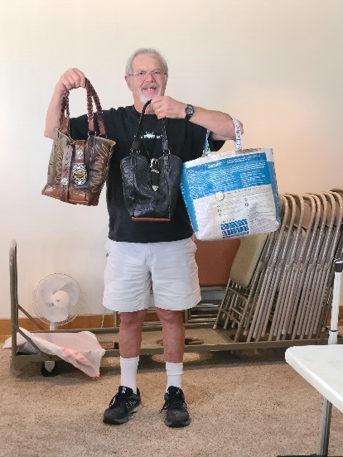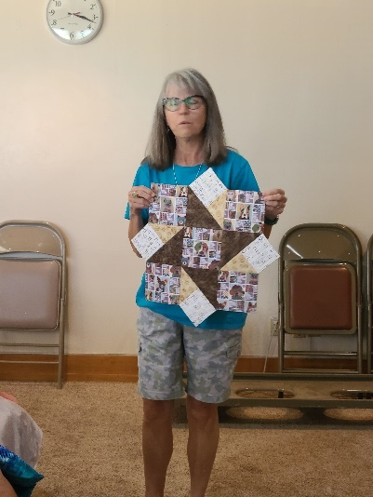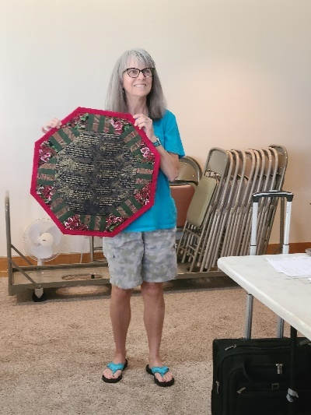
Kim Yakovleff Industrial Machine Bags Karen Moes Table Toppers

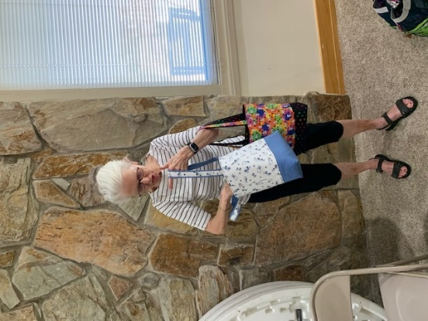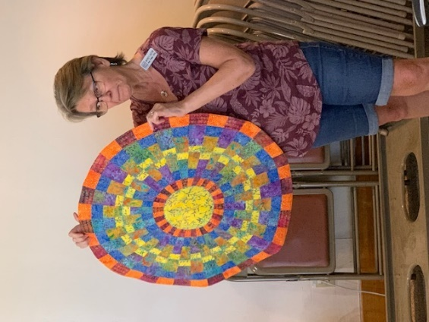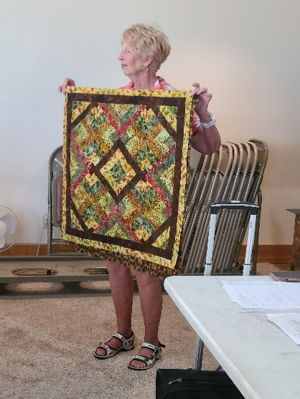
Billie Dunphy 2-child Totes Mickey Astin-Table Topper Missy Wignall Fun Quilt
Joyce Harlan Basket
Jan Tuller
2-Toppers
Mary Hartman
Game Bag
